**HomeWork**

**Class : IT0502**

**Student Name : Pham Duc Tin**

**Student ID : BH00128**

Summary

Trend

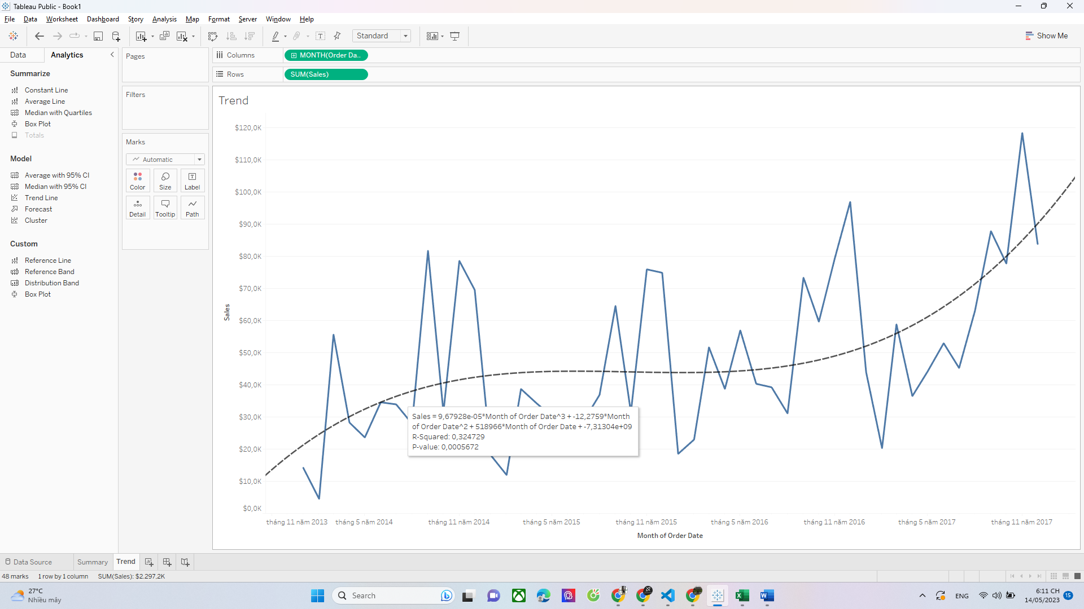

Sales Per Sub-category

Dashboard

-